The SWW DTP held its first official symposium on the 18th May, and we are pleased to announce that it was a very successful event! Carrying the broad theme of ‘Gendered Spaces’ the symposium was truly interdisciplinary, with sixteen speakers coming a range of backgrounds including Philosophy, Modern Languages, History, English and Politics to name a few.

Everyone ready and excited to start the day!

Due to the high numbers of fascinating and provoking submissions for the symposium, we split the morning into two panels: the first presented three twenty minute papers loosely based on gender theory, while the second featured seven five minute ‘flash’ papers on a range of topics.

Yanos Soubieski started us off with a presentation on “Gender Identity as a Space of Struggle”, contemplating gender as an imposed identity and whether it is possible to exist outside of it.

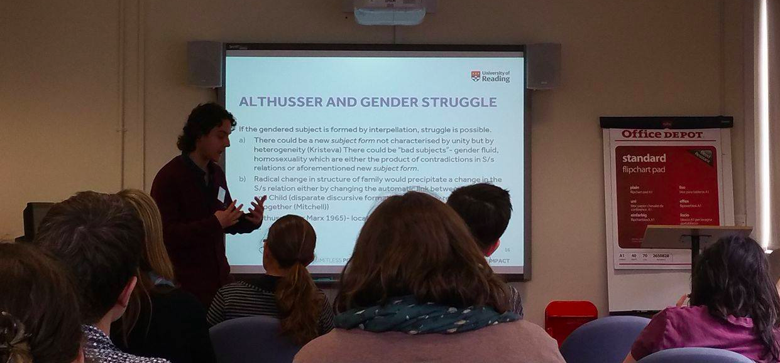
Yanos Soubieski ' Gender Identity as a space of struggle'

This set the scene for much of the rest of the day, introducing a range of gender theories for others to build upon. Ana Tomcic followed with a discussion of the interwar, gendered philosophies of H.D. and Sigmund Freud through her paper “Who can Enter the 4th Dimension? Gender, Class and Transcendental Eroticism in H.D. and Freud”, before Eleri Lloyd finished up the first panel with provoking thoughts on whether architecture can or should be gendered.

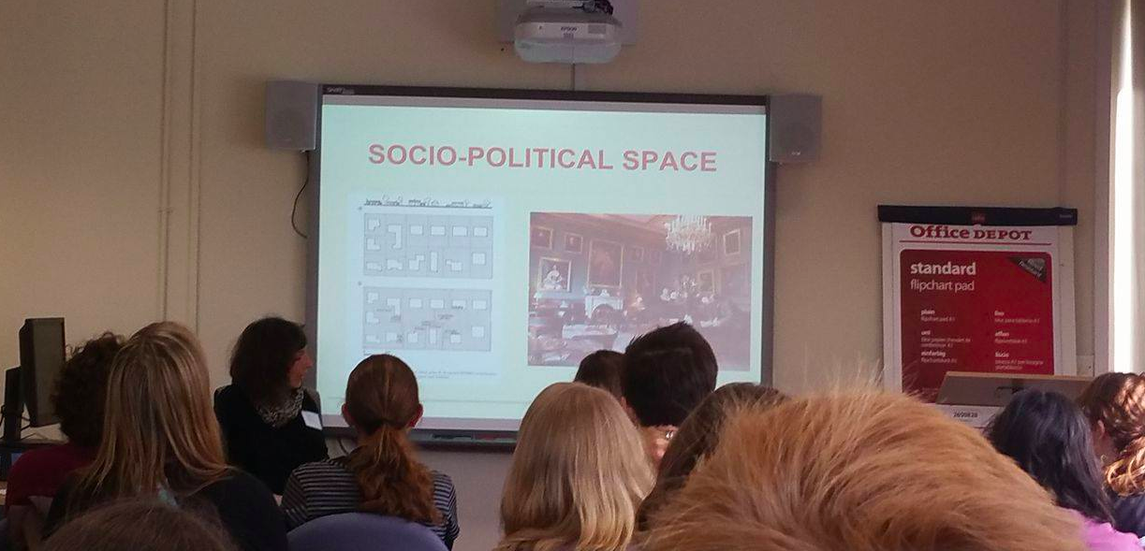
Eleri Lloyd 'Examining gender and space from the point of view of architecture as a creative act'

After the break, seven flash papers took us through a whirlwind of topics. In brief:

Kirsty Bolton - “That theire husbands shuld neuer see them in theyr child bed”: the fairy covenant and male exclusion from the childbirth room

Stephen Heptinstall - During Sickness: Experiencing the Shared
Space of the Farmhouse

Mariana Howell - Literary representations of motherhood and
Madness

Netta Chachamu - Equality and Diversity training at UK universities

Steven Roberts - The World’s First Widescreen Queen: Staging
Elizabeth II in CinemaScope Newsreels

Elizabeth Kajs - Käthe Kollowitz’s Explorations of Public and
Private

Justine Shaw – Maurice Merleau-Ponty and the maternal host

These all offered great material for discussion, and it was interesting to see that Kirsty’s discussion of the home as a private sphere for women during childbirth was mirrored to an extent in Stephen’s talk about how the quality of the home was changed during male sickness on 21st century farms. A lively discussion of maternity and expressions of gender then took us through to lunch.

After lunch, Kay Westoby kicked off our afternoon of sessions with an unflinching, thought provoking and, at points, humorous discussion of the body as a gendered space. Touching on some of the themes surrounding the body discussed earlier in the day, Kay highlighted ideas on the sensory intrusion of the feminine bodily functions of menstruation and ideas of contraception and penetration as facets which shape the space of the body. Jennie Lewis followed with a fascinating historical and theoretical paper on the development of boxing in the early 20th century and how it cultivated a new environment in which ideas of masculinity, both homosexual and heterosexual, could be practiced. Jennie used modern and historical examples to place her discussion in context, and, by focusing on ideas of masculinity rather than femininity, was a refreshing addition.
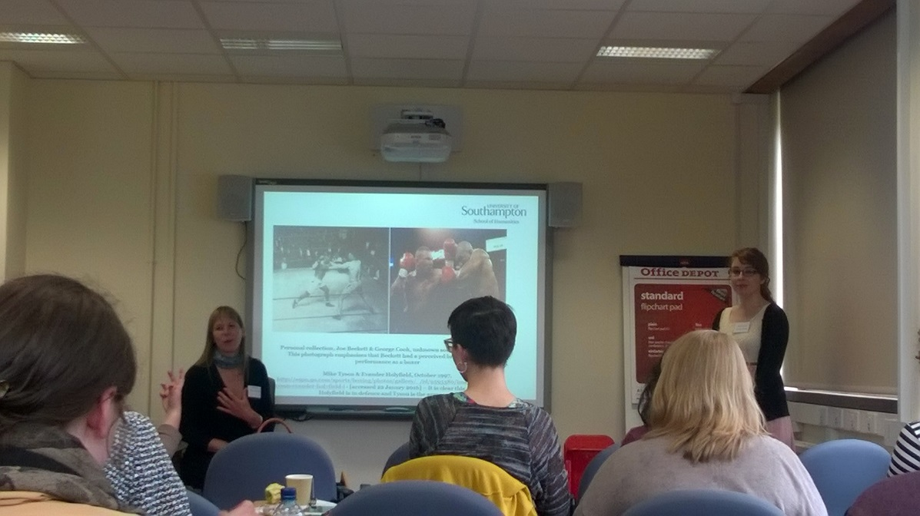
Jennie Lewis, ‘Boxing’s Manhood Formula: Hegemonic Masculinity and its influences on Early 20th Century Male Heterosexuality and Homosexuality’

Next, we went back even further in time to Roman Iberia where Lucy Elkerton took us through a range of mosaics and the representations of gender in mythical scenes. Like Eleri’s talk, Lucy’s paper was very visual and therefore interactive with the audience, presenting us with a range of images to engage with and consider. Lucy discussed the intention of those crafting these mosaics, the ideologies of the time relating to gender, and how the use of space within these buildings would have effected how the mosaics were seen, perceived and by whom. Each of these three papers sparked a range of questions and discussion which could have gone on indefinitely, but after the break it was time for our two final papers.

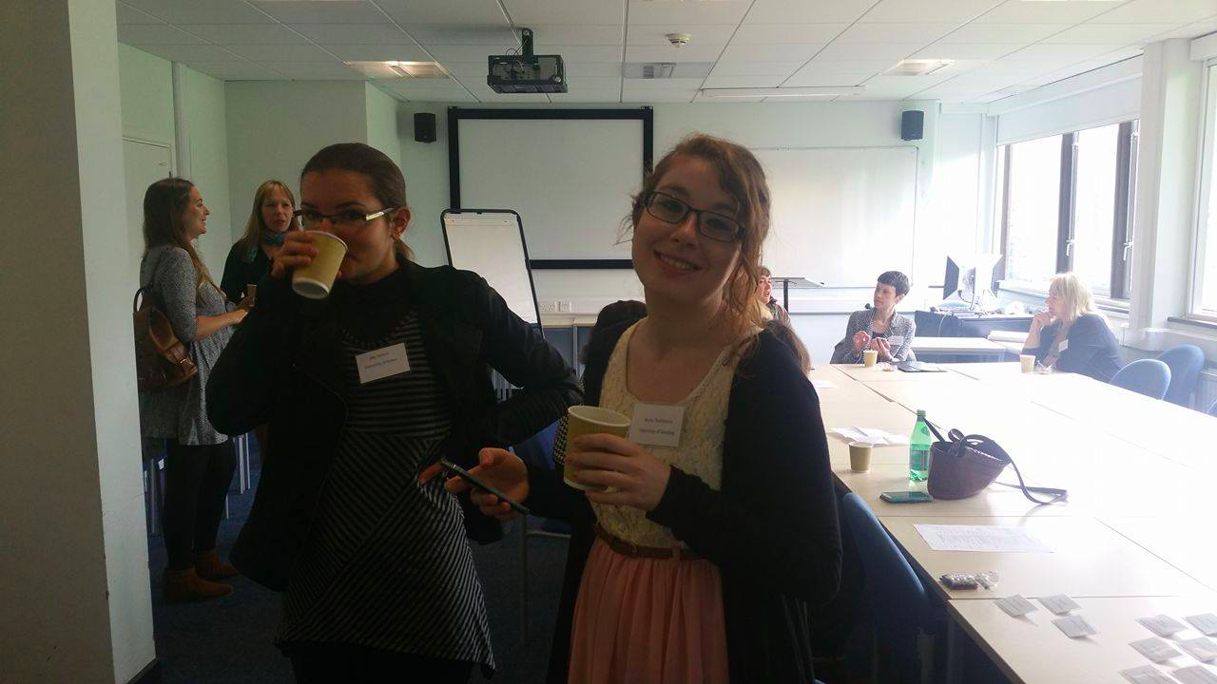
Discussion in the coffee break

Adam Vaughan started us off with his paper on identity performance in LGBTQ documentary film, and showed us clips from two documentaries: I am Divine, about the life of the eponymous drag Queen, and Mapplethorpe: Look at the Pictures, about a controversial photographer who, among other things, depicted graphic homoeroticism. Both documentaries presented individuals who pursued extremes and raised visibility for the LGBTQ community and prompted awareness and a mix of reactions among audiences and critics.

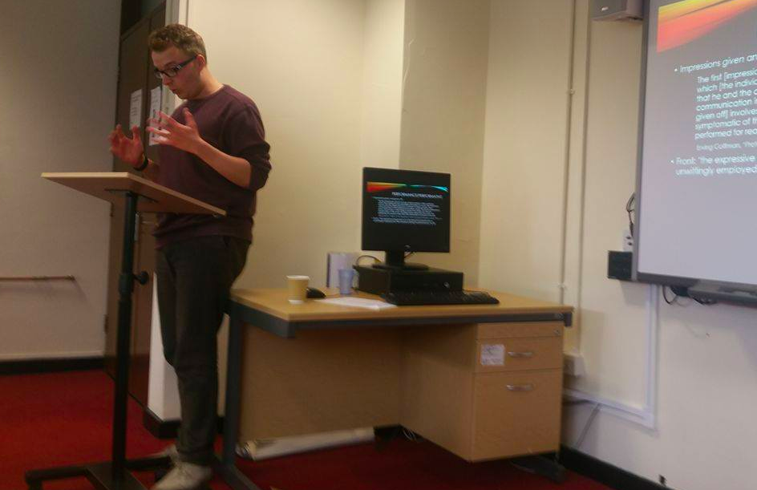
Adam Vaughan 'Identity Performance in LGBTQ film and documentary'

Finally, Sophie Payne, one of our organisers, presented on ‘Contemporary Feminist Protest in Germany and the UK’ with particular emphasis on the controversial group Femen. Sophie presented to us the group’s causes, their ideologies, media response and their socio-cultural background and then impartially let us as an audience discuss and decide what we thought about them. Sophie’s talk in many ways brought together some of the broader themes of the day and sparked questions, debate and a range of opinions about the very nature of feminism, what feminist protest should entail and how the issues and inequalities relating to the gendered spaces we live in can most effectively be overcome. After a lively and interactive discussion, everyone seemed to leave feeling inspired and as if they had learned something new, or been made to consider something from a new perspective.
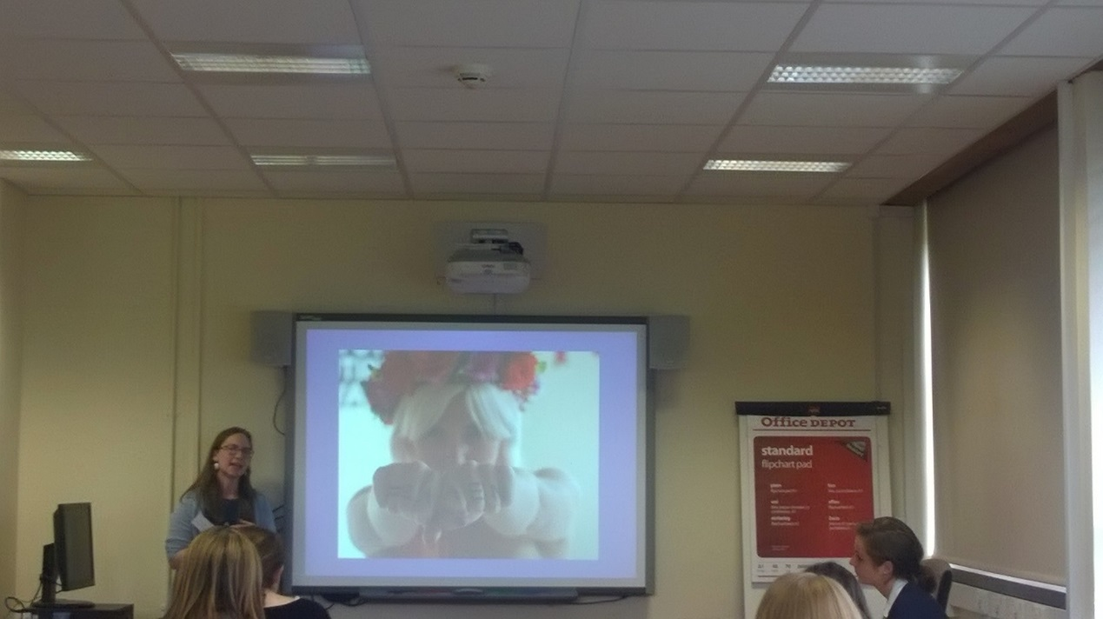
Sophie Payne, ‘Representations of Contemporary Feminist Protest in Germany’

Feedback at the reception afterwards let us know how much people enjoyed hearing talks from such a wide range of fields and interacting with people from disciplines and departments that they never usually would have the chance to. It seemed that the postgraduate-led environment had fostered a real feeling of uninhibited and supportive discussion, and led to a contagious enthusiasm both for our separate subjects and shared themes. We feel that the day allowed for strong networks to be developed, which should definitely pave the way for a second symposium! Thank you to everyone who talked, participated, attended and helped to make it such a rewarding day. Special thanks as well to the South West and Wales Doctoral Training Partnership for encouraging, facilitating and funding this event. We will keep you posted about future events!

